
NOIS

Department of Veterans Affairs
National Online Information Sharing
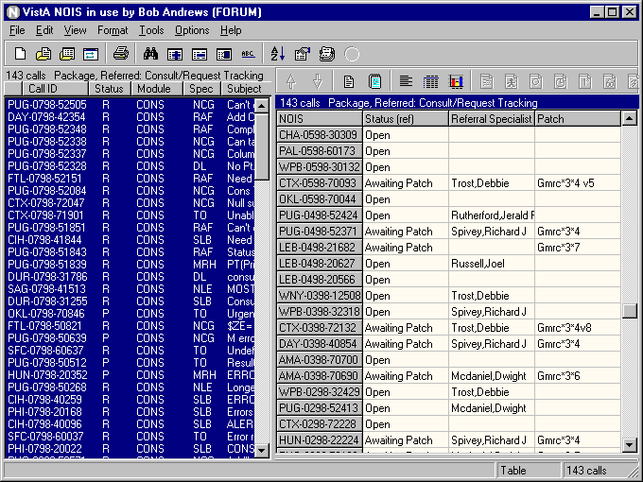
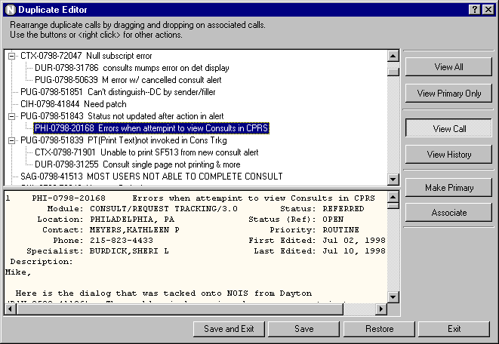
Training Examples
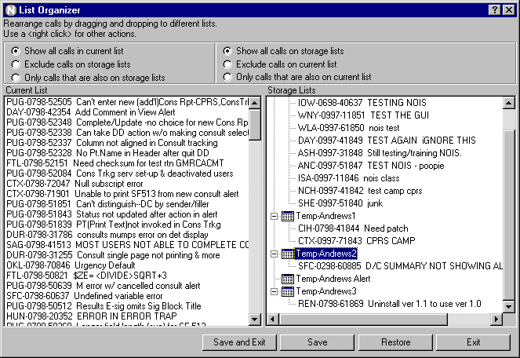
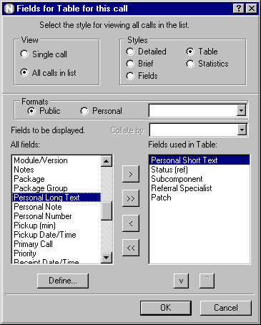

Referral Specialist

Introduction — Referral Specialist

These training examples represent common tasks performed by NOIS Specialists who develop and maintain VistA software. For NOIS on Forum, this includes Technical Service programmers. For NOIS installed at a local site, the process of referring problems is less common; although, you may organize so that some problems are referred to IRM staff that handle specialized problems.

As a NOIS Specialist you can edit calls. You can close and cancel any call, You can assign a support open status on calls requiring more background. You can also create batch edit, associate calls as duplicates, and create and edit web pages. You can use User Defaults (using List Manager to edit your defaults). You can also do anything a general user of NOIS can do (which is actually a whole bunch of stuff). If you need help with NOIS, contact a NOIS Coordinator. To see who is a NOIS Coordinator, use the NOIS menu on Forum for File Setup, enter SPEC and sort by NOIS Coordinator.

The examples here all relate to using the GUI. The only things you can't do with the GUI are User Defaults, Define a List, and File Setup.

Benefits

The benefit of NOIS is that you can track and organize reported problems. You can also review previous problems to search for potential solutions. NOIS allows you to communicate by leaving notes on calls when it is more convenient or you are unable to contact the site or support specialists. This is also true for your customer. It provides additional information related to the request such as information on software, patches, installations, and contacts. It allows you to work in a geographically distributed team organization. Hopefully it provides a better product and better service to the customer.

Common Lists

Look at the File menu, Most Recently Used menu; these are the last lists that you've used. If you haven't used the lists below, look them up. Use File menu, Select List to get the Select NOIS List form. Make sure Common is selected, and choose a list. You may have to enter a Specific entry. Experiment restricting your list entries. Notice how your Most Recently Used menu changes.

Referred calls for a package:
These lists are for referred calls for a package or module/version#.
Package, Referred: : <package>
Module/#, Referred: < module/version#>

Lists by Referral Specialist:
These lists are useful on calls where a referral specialist is assigned the call. You need to enter a specialist (usually yourself).
Ref Specialist, Not Closed: <specialist>
Ref Specialist: : <specialist>

Lists by Subcomponent:
These lists are useful on calls where the package has subcomponents to categorize the calls. You need to enter a subcomponent.
Subcomponent, Referred: <subcomponent>
Subcomponet: : <subcomponent>

Lists by Package and Developing Office:
These list are useful for looking at all calls for a package or all calls developed at an office (CIOFO).
Module/#:< module/version#>
Package: <package>
Ciofo, Dev Open: <office>
Ciofo, Dev Referred: <office>
Ciofo, Dev: <office>

Other lists:
MRA: <person> last alerts processed
MRE: <person> last edited calls
Site: <location> all calls from this site
Site, Not Closed: <location> all unresolved calls from this site

Editing Calls

- Edit a Call
Select the call you want to edit. Use Edit menu, Edit Call to bring up the Edit Call form. Click on the notes tab. Browse to another call on the main form. Note that you get a warning that you are viewing a different call than the one you are editing. Copy some text from the call you are viewing and paste it as a note on the call you are editing (use your right mouse button, or simply drag and drop the text). Spell check the new entry (use the right mouse button). Save the call.

- Make a Note
Select the call you want to edit. Use Edit menu, Make a Note to bring up the Make a Note form. Enter some text. Paste in a common response (use your right mouse button). Note: if you don't have any common responses defined — cancel the Make a Note form and use the Options menu, Define Responses to add a common response — then make a new note and paste your response.

- Edit Personal Fields
Select the call you want to edit. Use Edit menu, Edit Personal Fields to bring up the Edit Personal Fields form (you can also Edit Call form). Make some entries and click the Save button

- Batch Edit some calls
Use Edit menu, Batch Editor to bring up the Batch Editor form). Make some entries and click the Save button. You are now presented with the Apply Batch Edits form. Review the edit information you have made and select the calls you will apply the edits to. Click the Apply button to make the changes or click Cancel to go back to the Batch Editor.

- Associate a Call as a Duplicate
Select the call you want to make a duplicate. Use Edit menu, Associate Call to bring up the Associate Call form. Select a call in the list that is the duplicate. If the call is not on the list, look up the call. Click the OK button to make the association.

- Use the Duplicate Editor
Use Edit menu, Duplicate Editor to bring up the Duplicate Editor form. Experiment with using the buttons and right mouse clicks. Drag and drop calls onto other calls. Notice how the primary call changes. Only save changes if you are sure these calls are duplicates; otherwise, exit.

Reviewing Calls

- Select a list of calls (restrict it to 5 entries)
Use File menu, Select List. Select a list. Under Restrictions, select Last # of calls and enter 5. Click OK

- Display all the calls in Detailed format
Use Format menu, Change Format. Under View, select All calls in list. Under Styles, select Detailed. Click OK.

- Display all calls in Brief format
Use Format menu, Change Format. Under View, select All calls in list. Under Styles, select Brief. Click OK.

- Display a Fields format on all calls for the fields Module and Location
Use Format menu, Change Format. Under View, select All calls in list. Under Styles, select Fields. Clear the fields in display by clicking the << button. Select the field Module/Version and click the > button (you could also just double click). Select the field Location also. Click OK.

- Display a Table format on all calls using a selected format
Use Format menu, Change Format. Under View, select All calls in list. Under Styles, select Table. Under Format, select Public and choose a format from the drop-down list. Click OK.

- Display a Statistics format on all calls for Module and Location
Use Format menu, Change Format. Under View, select All calls in list. Under Styles, select Statistics. Select fields (as described in #4). Click OK.

- Display the same Statistics format and collate by Module
Use same instructions as #6, except also select Module/Version from the Collate by drop-down list.

- Save a personal format that has fields and use it to display all calls in a Fields format
Use Format menu, Change Format. Under View, select All calls in list. Under Styles, select Table. Clear the fields in the display by clicking the << button. Select the fields you would frequently use. Order the fields using the v or ^ buttons. Click the Define button and type in a name for this format. Click the New button. Now, under Formats when select Personal, you can make this selection. Click OK

- Change back to a standard format
Use Format menu, Standard Format. The display goes back to a detailed format on a single call.

- Sort calls on the list by site by clicking the list header
Click a title on the current list. The list is sorted by that category. Click it again. The list is sorted in reverse order. Click the first, untitled section — this is sorted by date received (the default).

- Sort the list by Site, Status, and Priority
Use Tools menu, Sort List to bring up the Sort Call form. Select fields on how you want the list sorted. Click OK.

- Check the Other Information on the call
Select the call on the list. Use View menu, Other Information menu and make various selections. The information appears in a lower pane on the display. You can size the display by dragging the horizontal border. Notice how the Print menu (under the File menu) changes with the selections.

- Look at the Graph format
Select a list with multiple calls on it. Use Format menu, Graph to.bring up the graph display. Change the fields, change the style, change the options. Experiment. If you are on a bar chart, you can zoom the display by dragging from left to right to generate the window you want enlarged. To unzoom the graph, drag from right to left and upward, or make a new selection of field or style. When you are done looking at graphs, Use Format menu, Graph to toggle off the display. You can also select a call on the list; the display will return to a standard format.

Finding Calls

- Look up a call
Use File menu, Select Call to bring up the Select NOIS Call form. If you know the last 5 numbers of the call (example: 50001), enter those and click the Submit button. You can then select the call from those found. If you know the entire call ID (example: SLC-0798-52604), enter it and click Submit. If you know the location abbreviation and approximate date the call was opened, enter the abbreviation - month and year (example: TUA-0798), then select from the list. Click OK for the selection.

- Add this call to your Temp list
Use File menu, Save List As to bring up the Save NOIS Calls to a Storage List form. Note: if you don't have a personal storage list, you will be prompted to create one. If you have multiple storage lists you can select them from the drop-down list. Select Add calls to list and click OK. Look at your Most Recently Used lists under the File menu.

- Find text in the display
Select a call. Select the display (the cursor must be in the text). Use Edit menu, Find to bring up the Find form. Type in the text you want to find (example: undefined). Click the Find Next button. To find more occurrences use the F3 button.

- Find text using Text Finder
Use Tools menu, Text Finder to bring up the Text Finder form. Select Last number of calls and enter 500. Enter the text you want to find in the calls (example: undefined). Click OK. Examine some of the calls to make sure they contain the text.

- Use queries to find calls. Save the list
Use File menu, Clear List to start fresh. Use Tools menu, Query to bring up the Query form. Enter in the Field box: Module and <enter>. Enter in the Module/Version box: TIU and <enter>. Click the And selection. Enter in the Field box: Location <enter> and in the Location box: West Palm Beach <enter>. Click OK. Use File menu, Save List As to save this list (use Replace this list with these calls) and click OK

- Use graphs to find the selections
Use Format menu, Graph to turn on the graph display. Select Status from the Fields list. Select a Pie style. With your cursor over the closed calls, do a right click. Select the menu item: Select where Status = Closed. Notice your list has changed to only the closed calls. Refresh the list by selecting Refresh List from the File menu (or use F5). Select a call in the list to turn off the graph display.

- Sort the list and use selected calls to find calls
Click Status on the list header. Use Tools menu, Select from List and select the Selected Calls tab. Highlight (drag over) the closed calls. Click OK. You now have the closed calls. Refresh the list (F5).

- Use a query to select calls
Use Tools menu, Select from List and select the Query tab. Type in Status <enter> in the Field box. Type in Closed <enter> in the Status box. Click OK. Same results. Refresh the list (F5).

- Select calls using the list of STATUS: CLOSED. Refresh the list
Use Tools menu, Select from List and select the Lists tab. Type in Status <enter> in the List box. Type in Closed <enter> in the Status box. Click the Include List button (or <enter>). Click OK. Same results. Refresh the list (F5).

- Use graphs and select multiple Specialists
Use Format menu, Graph to turn on the graph display. Select Specialist from the Fields list. Select a Pie style. With your cursor over a section of the pie, do a right click. Select the menu item: Add to multiples where Specialist = <somebody>. Click over another section, adding other specialists to your selections. You can review your selections using the View Multiples action. Now use Select Multiple Specialist. Your list is now only those selections.

- Find the calls on this list that you have automatic notification on
Use Tools menu, Notifications to bring up the Notifications form. Select the Find tab. Select Only calls in the current list. Click OK. Refresh the list (F5) and repeat this except select a different user (example: Enter a specialist on a call that is in the list).

- Organize calls in your temp lists
Select your list of recent alerts (File menu, Select List, select MRA:, and enter your name). Use Tools menu, List Organizer to bring up the List Organizer form. Click the right mouse button in the Storage Lists section. Select New List. Click on the list. Create a few more lists. Move calls between your current lists and your storage lists. Experiment. Use the right mouse button actions to rename a list, delete a list, view the call. Save your changes. Select one of your temp lists (File menu, Select List, select Owned, select the list). Use the Batch Editor to apply a entry for Personal Short Text to the calls.

Other Stuff

- Alert someone
Use Tools menu, Notifications to bring up the Notifications form. Select the Notify tab. Select Alert. Select any calls you want to send with the alert. Select users you want the alert to go to by selecting them from the Users box. You must click on the user so that they appear in the Send to list. Include yourself to see how alerts work (and to do #3). Note: You can remove a user from this list by double clicking. Type in the Subject of notification. Click OK.

- Process an alert
When you have new alerts the Process Alerts button on the tool bar turns red. Note: The icon for NOIS also turns red, so even if your application is minimized, you can see the change on your taskbar (also if you'd like a sound to play, see Icons and Sounds in the online help). To process alerts, click the Process Alerts button or use Tools menu, Process Alerts. The subject of the call will be appended with who sent the alert.

- Remove alerts
If you receive alerts on calls you don't want to be alerted on, use Tools menu, Notifications to bring up the Notifications form. Select the Remove tab. Select the calls you don't want to be alerted on. Click OK. You can do this by using View menu, Other Information and selecting Notifications. Note: If you are using Notification by Affiliation or Active-Update lists to define your notification, you will still be notified on calls meeting those criteria.

- Edit a web page
Use Tools menu, Edit Web Page to bring up the Edit Web Page form. Enter the package. Use the Selection drop-down list to find the web page you wish to edit. The information on the web page will be filled in. Edit any portion of the title, problem, and solution. Click Save. Review the web page by browsing to it from the Solution Index page.

- Patch Tracking
Use Tools menu, Profile Information to bring up the Profile Information form. Click on the Patch tab. Select a patch and click on the various reports. Click on the Location tab. Select a location. Click on the reports that have to do with patches. Click on the Module tab. Select a module. Click on the reports related to patches.

- Package Tracking
Same as #7 except only look at Location and Module tabs. Look for reports related to package installs.

Tips

Sign on to NOIS and keep it minimized while you work on other things. Specialists on Forum have a four hour timeout. You can still monitor alerts as you work.

Use Notification by Affiliation for all calls for the packages you develop and maintain. Using List Manager, enter UD for user defaults. Set the field for Notify by Affiliation to Referred. Enter the Package Affiliation multiple with packages you want alerts on.

Use the field Referral Specialist, Patch, Subcomponents, and Keywords to categorize calls within your workgroup. You may want to coordinate this with the Custome Service team affiliated with the package.

Use the List Orgainizer to put problems into a group of the same type of problems. Use the Duplicate Editor whenever you can match duplicates. Use Personal Fields to further categorize calls that you may want to put into a spreadsheet. Use the Batch Editor to assign patch numbers, personal fields, and keywords.

Quiz

- What list would you use?
  - You processed your alerts but didn't get a chance to review them.
  - You want to look for some calls your coworker edited.
  - You need the referred calls for a package.

- How would you see a distribution of referred calls for your package by location?

- For the current call, where do you find out?
  - who last edited it and what was changed
  - who is automatically being alerted on this call.

- How do you go back to the calls you were reviewing before you did that selection query that found no calls?

- How would you find out if a site has all the patches for a package installed.

- How would you find the sites that have installed your test patch.

Answers
1a. MRA: <yourself>, 1b. MRE: <your coworker, 1c. Package, Referred: <package>
2. Select Package, Referred: <package> use a Statistic format for Location, or use a Graph format for Location.
3a. Status History/Audits, 3b. Notifications/List (these are buttons on the display toolbar)
4. Before doing the query, save the list to your temp list. Then you can return to those calls by doing a refresh list (F5).
5. Use Profile Information, Module tab, select module, the report Patches Not Installed (at location), and site. Also from the Location tab, select site, the report Patches Not Installed (for Module), and module.
6. Same as #5 but use the report Test Patches Installed.

